Name (username): Xingjian Diao(xid32), Man Hei Casper Cheng, Tianrun Gu(tig19)

a) 1NF

* AB→E
* ABE→E
* ABE→D
* B→D
* B→E
* C→D
* C→E
* C→F
* DC→A
* DF→A
* E→D
* 2NF (remove partial dependency)
* AB→E delete because B→E
* ABE→E delete because E→E
* ABE→D delete because E→D
* B→D
* B→E
* C→D
* C→E
* C→F
* DC→A
* DF→A
* E→D
* 3NF (remove transition dependency)
* B→D delete because B→E and E→D
* B→E
* C→D delete because C→E and E→D
* C→E
* C→F
* DC→A delete because C→F and DF→A
* DF→A
* E→D
* Primary key
* BC is the key because not appear to right side
* BC+ →BCDEFA
* B→E pk:B
* C→E pk:C
* C→F pk:C
* DF→A pk:D,F
* E→D pk:E
* R1(B, E)
* R2(C, E, F)
* R3(D, F, A)
* R4(E, D)
* R5(B, C)

All relations are in BCNF form

b) Conclusion: The relation is lossless.

Initialize the Table look like this

|  |  |  |  |  |  |  |
| --- | --- | --- | --- | --- | --- | --- |
|  | A | B | C | D | E | F |
| R1(B, E) | × | a2 | × | × | a5 | × |
| R2(C, E, F) | × | × | a3 | × | a5 | a6 |
| R4(D, F, A) | a1 | × | × | a4 | × | a6 |
| R5(E, D) | × | × | × | a4 | a5 | × |
| R6(B, C) | × | a2 | a3 | × | × | × |

Using BC->BC, we get

|  |  |  |  |  |  |  |
| --- | --- | --- | --- | --- | --- | --- |
|  | A | B | C | D | E | F |
| R1(B, E) | × | a2 | a3 | × | a5 | × |
| R2(C, E, F) | × | × | a3 | × | a5 | a6 |
| R4(D, F, A) | a1 | × | × | a4 | × | a6 |
| R5(E, D) | × | × | × | a4 | a5 | × |
| R6(B, C) | × | a2 | a3 | × | a5 | × |

Using C-> F, we get

|  |  |  |  |  |  |  |
| --- | --- | --- | --- | --- | --- | --- |
|  | A | B | C | D | E | F |
| R1(B, E) | × | a2 | a3 | × | a5 | a6 |
| R2(C, E, F) | × | × | a3 | × | a5 | a6 |
| R4(D, F, A) | a1 | × | × | a4 | × | a6 |
| R5(E, D) | × | × | × | a4 | a5 | × |
| R6(B, C) | × | a2 | a3 | × | a5 | a6 |

Using E-> D, we get

|  |  |  |  |  |  |  |
| --- | --- | --- | --- | --- | --- | --- |
|  | A | B | C | D | E | F |
| R1(B, E) | × | a2 | a3 | a4 | a5 | a6 |
| R2(C, E, F) | × | × | a3 | × | a5 | a6 |
| R4(D, F, A) | a1 | × | × | a4 | × | a6 |
| R5(E, D) | × | × | × | a4 | a5 | × |
| R6(B, C) | × | a2 | a3 | a4 | a5 | a6 |

Using DC-> A, we get

|  |  |  |  |  |  |  |
| --- | --- | --- | --- | --- | --- | --- |
|  | A | B | C | D | E | F |
| R1(B, E) | a1 | a2 | a3 | a4 | a5 | a6 |
| R2(C, E, F) | × | × | a3 | × | a5 | a6 |
| R4(D, F, A) | a1 | × | × | a4 | × | a6 |
| R5(E, D) | × | × | × | a4 | a5 | × |
| R6(B, C) | a1 | a2 | a3 | a4 | a5 | a6 |

2.

1. FD1: MedicineID → Ingredients, Uses, Warnings, Directions
2. FD2: OrderID → OrderDate, PatientID, TotalPrice
3. FD3: PatientID → Address, City, State, ZipCode, PhoneNumber
4. FD4: MedicineID, OrderID → MedicineQuantity
5. Combine all attributes into relation R(MedicineID, Ingredients, Uses, Warnings, Directions, OrderID, OrderDate, PatientID, TotalPrice, Address, City, State, ZipCode, PhoneNumber, MedicineQuantity)
6. Using MedicineID → Ingredients, Uses, Warnings, Directions to decompose R, we get: R1(MedicineID, OrderID, OrderDate, PatientID, TotalPrice, Address, City, State, ZipCode, PhoneNumber, MedicineQuantity) in 1NF  
   R2(MedicineID, Ingredients, Uses, Warnings, Directions) is already in BCNF form
7. Using OrderID → OrderDate, TotalPrice to decompose R1, we get: R11(MedicineID, OrderID, PatientID, Address, City, State, ZipCode, PhoneNumber, MedicineQuantity) in 1NF R12(OrderID, OrderDate, TotalPrice) is already in BCNF form
8. Using PatientID → Address, City, State, ZipCode, PhoneNumber to decompose R11, we get: R111(MedicineID, OrderID, PatientID, MedicineQuantity) in 1NF

R112(PatientID, Address, City, State, ZipCode, PhoneNumber) is already in BCNF form

1. Using MedicineID, OrderID → MedicineQuantity to decompose R111, we get: R1111(MedicineID, OrderID, PatientID) in 1NF

R1112(MedicineID, OrderID, MedicineQuantity)is already in BCNF form

1. Using OrderID → PatientID to decompose R1111, we get: R11111(MedicineID, OrderID) in BCNF form

R11112 (OrderID, PatientID) is already in BCNF form

1. R1(MedicineID, Ingredients, Uses, Warnings, Directions)
2. R2(OrderID, OrderDate, TotalPrice, PatientID)
3. R3(PatientID, Address, City, State, ZipCode, PhoneNumber)
4. R4(MedicineID, OrderID, MedicineQuantity)
5. R1, R2, R3,R4 are in BCNF form

3.

a)

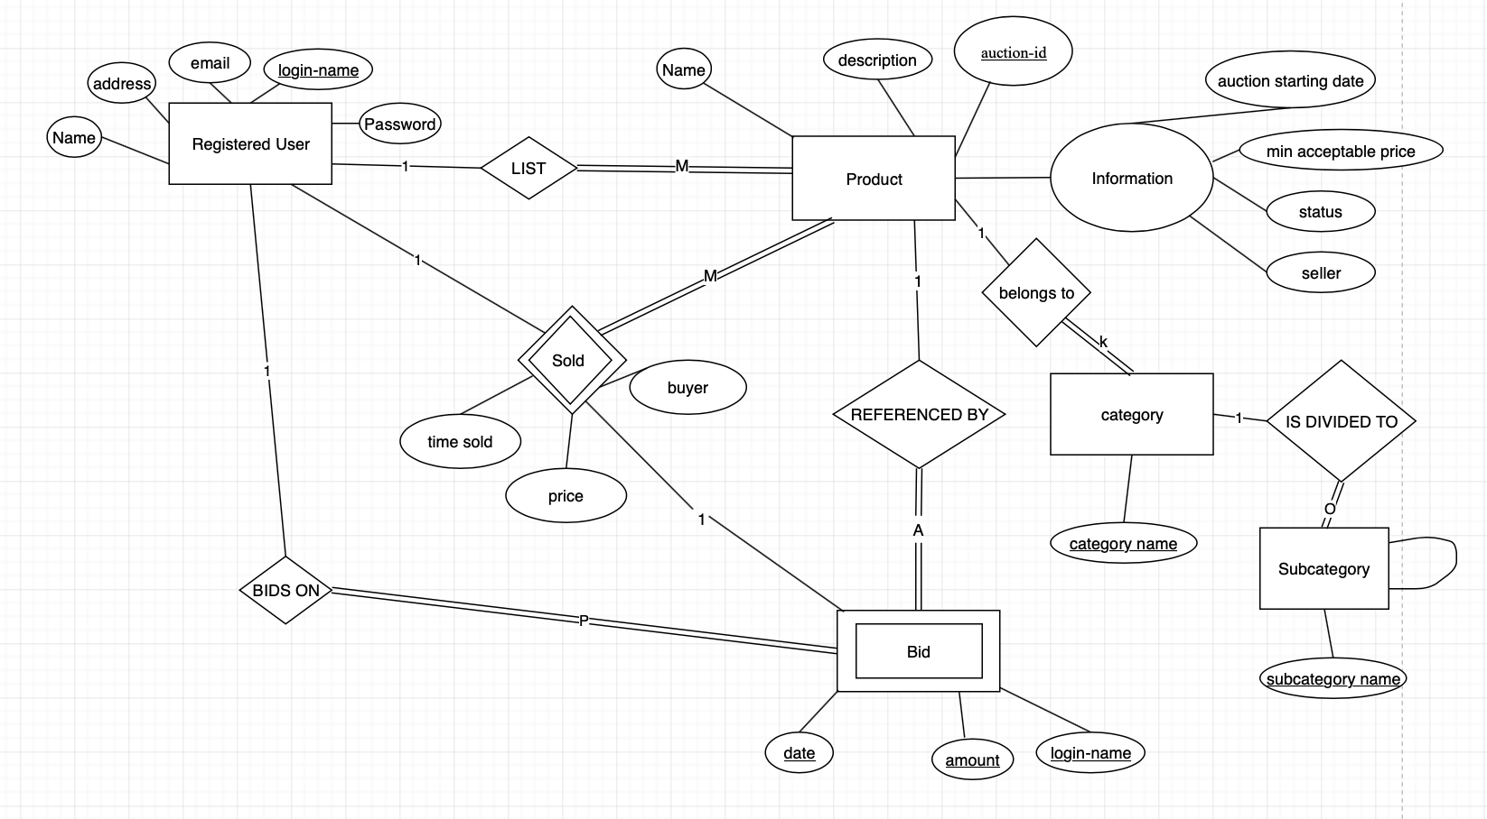

b)

The resulting schemas after mapping:

RegisterUser (login-name, email, address, Name, Password)

Product (auction-id, Name, description, information_auctionStartDate, information_minPrice, information_status, information_seller)

FK(information_seller) ->RegisterUser(login-name)

Bid(login-name, date, Name, amount)

FK(login-name) ->RegisterUser(login-name)

FK(Name) -> Product(auction_id)

SoldRecord (date, buyer, price, auction_id)

FK(auction_id) -> Product(auction_id)

FK(buyer) -> RegisterUser(login-name)

Category (auction_id, category_name)

FK (auction_id)->Product(auction_id)

Subcategory(subcategory_name, category_name)